# Summary

Apply for **Temporary or permanent withdrawal** from a current course using SITS Self-Service

**Log in to SITS Surrey Self-Service**

Access to SITS e-Vision is available from the web browser and enter your normal username and password <https://sits.surrey.ac.uk/live/sits.urd/run/siw_lgn>

**Access Apply for suspension or withdrawal**

From the **Registration** menu select the option **Apply for suspension or withdrawal**

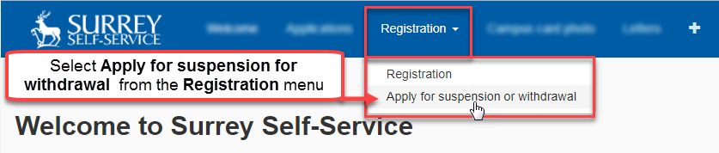

A summary of the process and guidance is provided

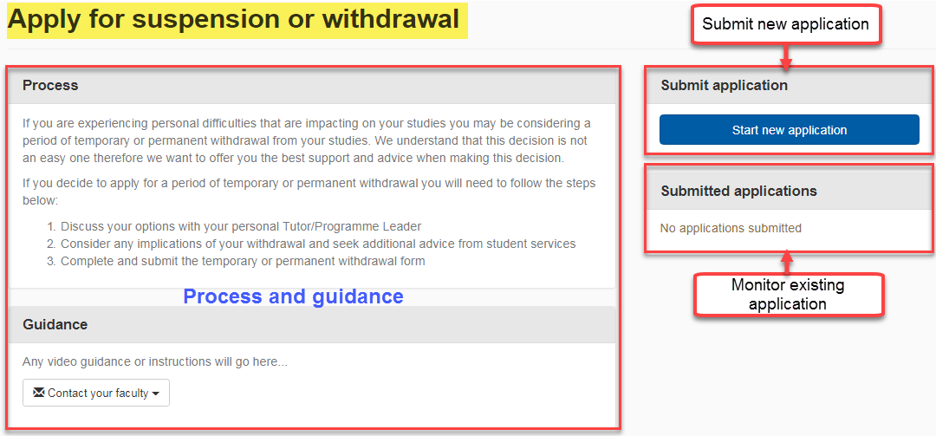

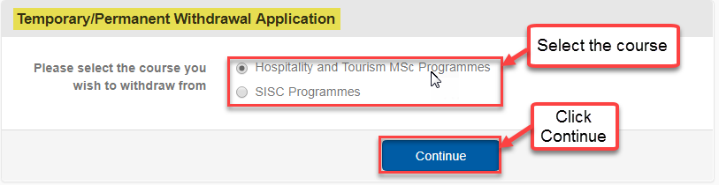**Select Course**

Your active course(s) will be displayed. Click to select the course from which you wish to withdraw

**Student/Programme details**

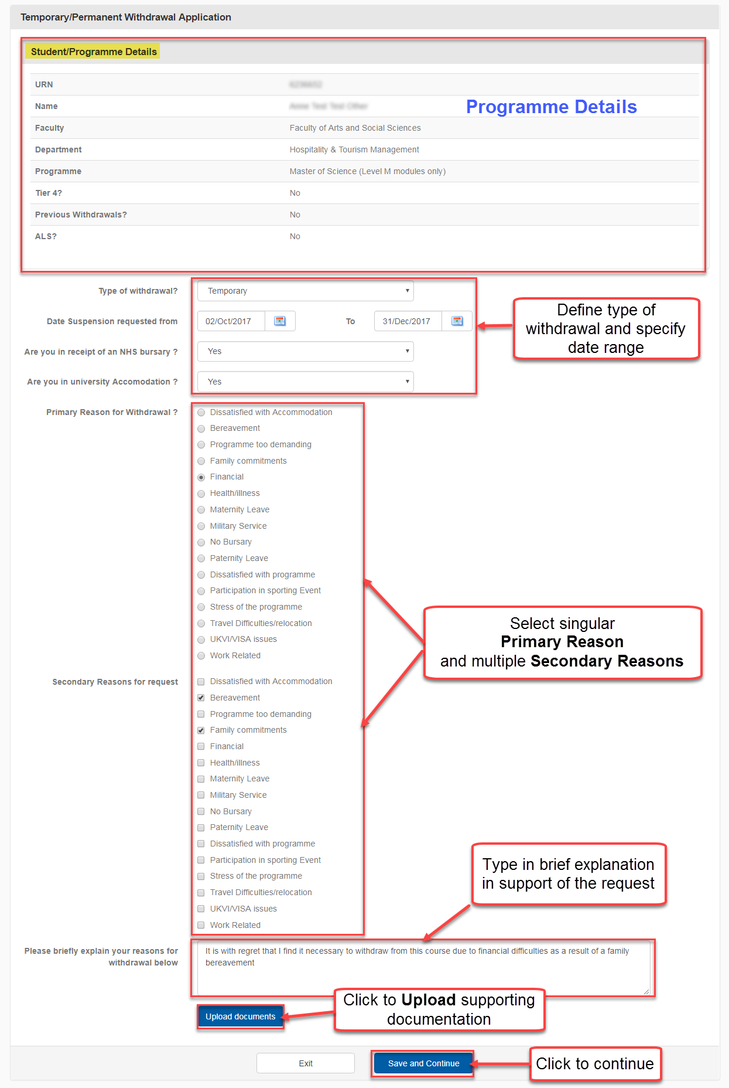

**Uploading Supporting documents**

Click **Upload Documents** to upload supporting documentation

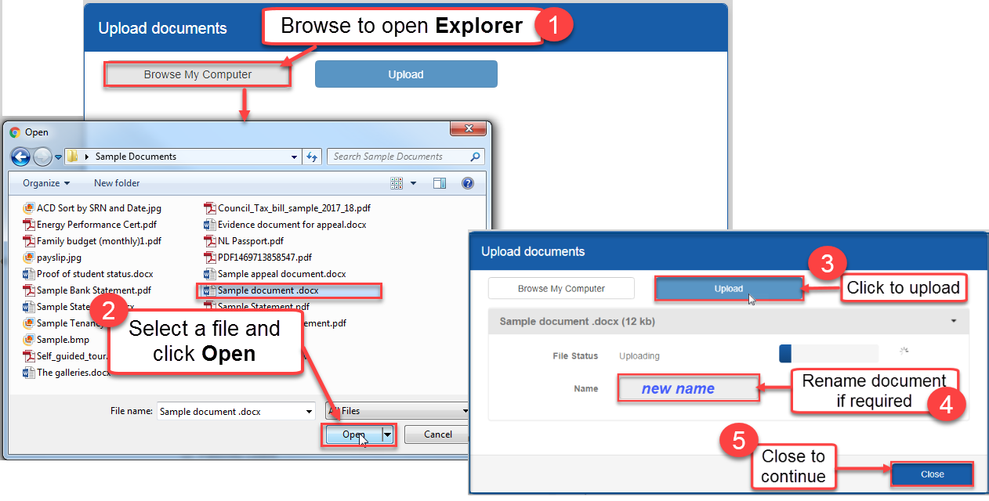

**Completing your application**

Click **Save and Continue** to submit your application for withdrawal (you will be alerted to any missing or incomplete fields)

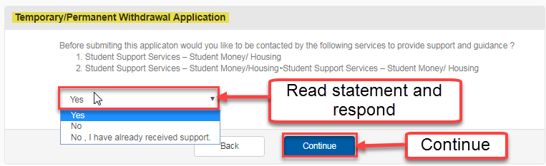

If you select the response **Yes** to the above statement this indicates that you are requesting more support and your application will be placed in a **Hold** state while support is being provided and the following **Application is on hold** screen is displayed stating that you will be contacted by the relevant department regarding the provision of additional support and guidance.

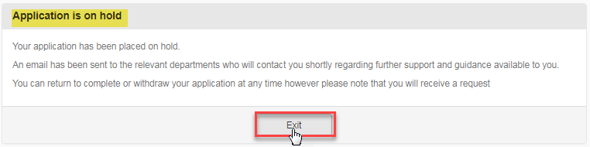

**View/Edit submission**

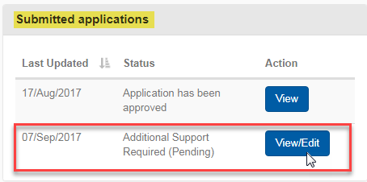On clicking **Exit** you will be returned to the starting **Apply for suspension or withdrawal** screen

The status of an application is listed in the **Submitted applications** section. Where additional support has been requested *(see ‘Completing your application’ above)* the message **“Additional Support Required (Pending)”** is displayed

**Submitting/withdrawing your application**

Clicking on the **View/Edit** action button will re-open the **Student/Programme Details** screen related to that specific application.

If there is no outstanding support issue select the option to **Submit Application** and respond to the following **Submit Application** prompt with **Next.** A confirmation of your submission will be displayed

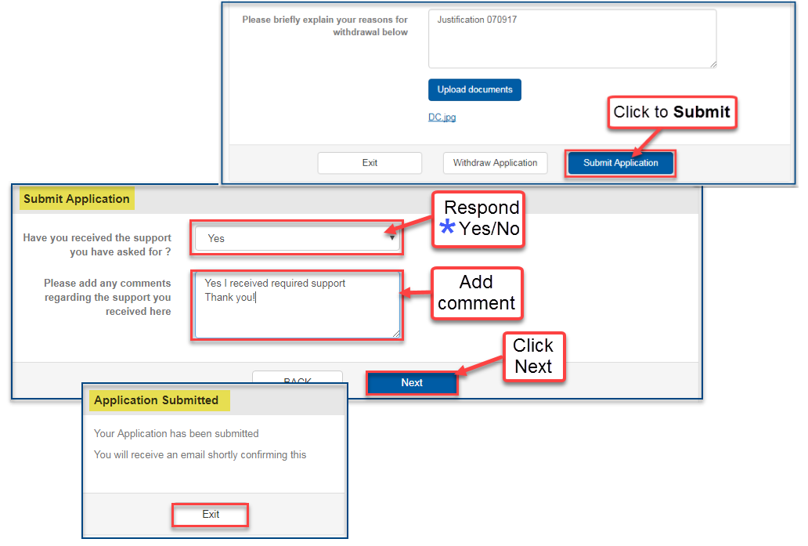

Selecting the **No** option to the prompt ***“Have you received the support you have asked for”***(**\***asterisked above) will result to the application entering the pending state indicated by the message **Additional Support Required (Pending)**

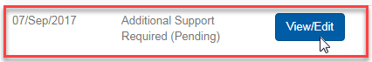

To **Withdraw** **Application** select the option at the bottom of the **Student/Programme Details** screen

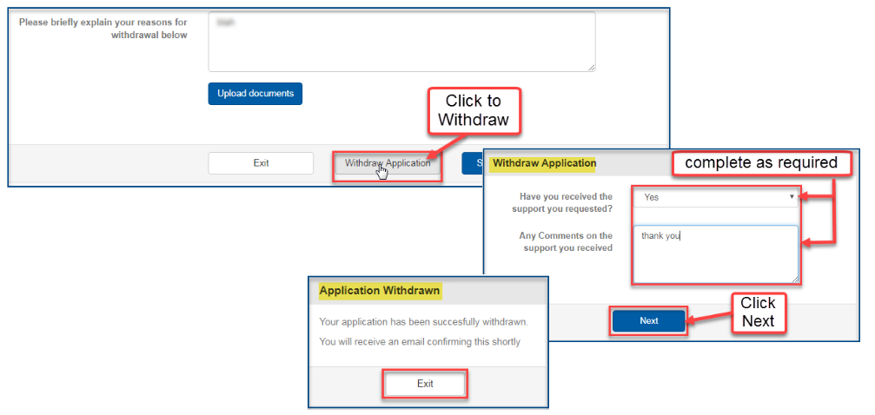

**View Application**

Selecting the option **View** from the Submitted applications list displays the **Withdrawal Application** screen which is divided into three primary sections; **Student/Programme Details; Application Details; Application’s Audit Trail.**

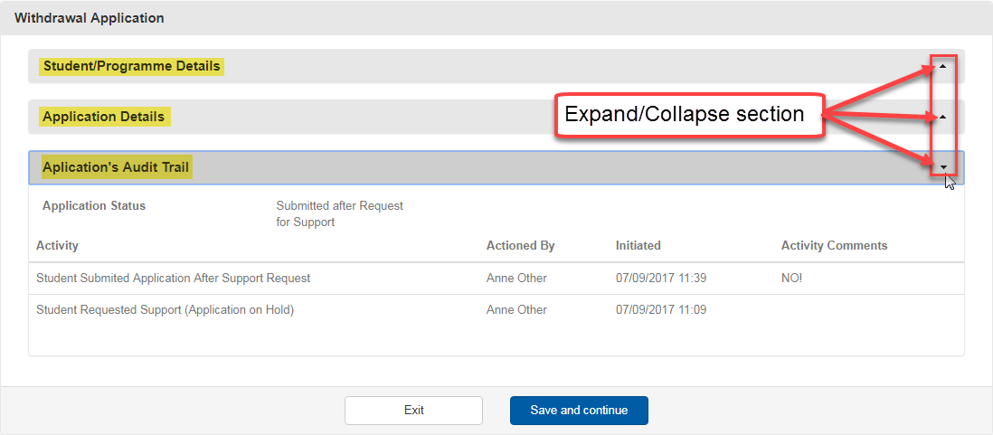

Use the up/down chevron  to expand or collapse the section or simply double click the mouse button

**Logging out of Surrey Self-Service**

When your application is completed please click **Logout** next to your user name at the top right of the screen