Introduction

All research students are required to have at least one supervisory session per month. This system allows you to create a record of your supervisory meetings, which is helpful for:

* Documenting and clarifying what has been discussed and agreed at meetings;
* Forming a repository of key decisions taken, which will help with writing the thesis;
* Facilitating early identification and resolution of issues.

Access to PGR Monthly Meeting

**Login to** [**Surrey Self-Service**](https://sits.surrey.ac.uk/live/sits.urd/run/siw_lgn) **navigate to Research programme details and then to Monthly Supervisions option**

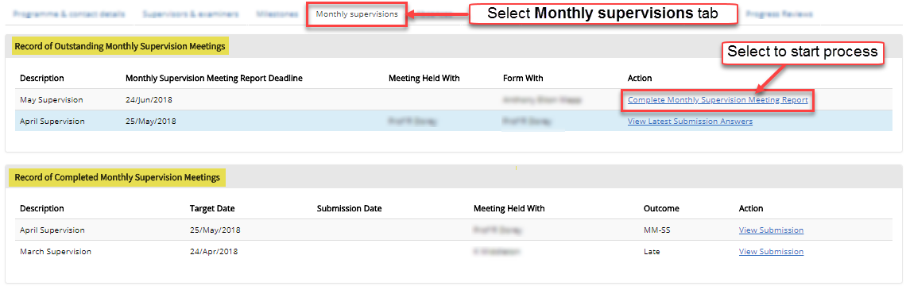

There should be at least one Monthly Supervision Meeting Report under the ‘Record of Outstanding Monthly Supervision Meetings’ heading (above). When you are ready, and before the submission deadline, click **Complete Monthly Supervision Meeting Report** link.

**A summary Welcome screen is displayed with related guidance**

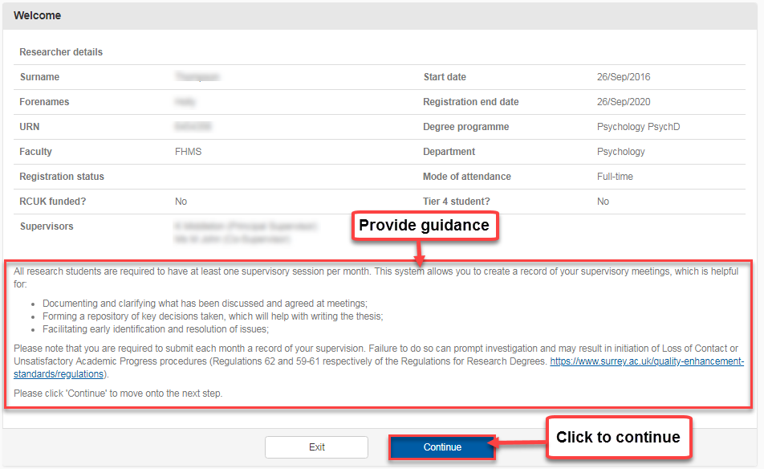

On the next screen, you are invited to complete a series of questions, provide a written summary of the meeting and/or upload of any meeting notes (i.e. Microsoft Word document)

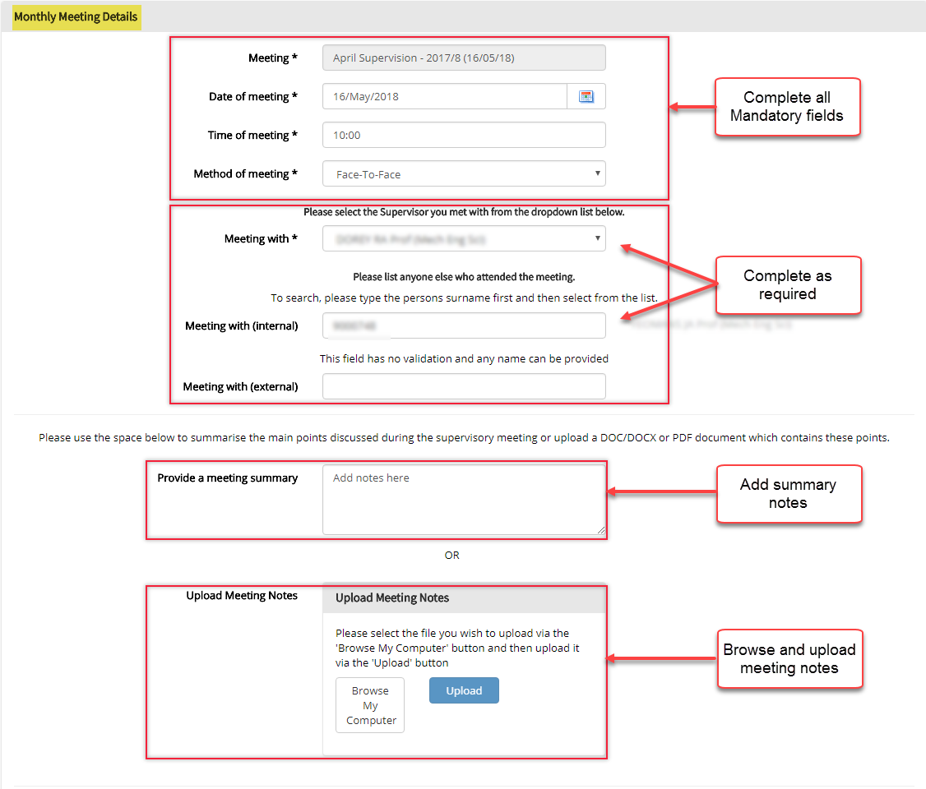

Agreed targets should be listed in a table below the Monthly Meeting Details section.

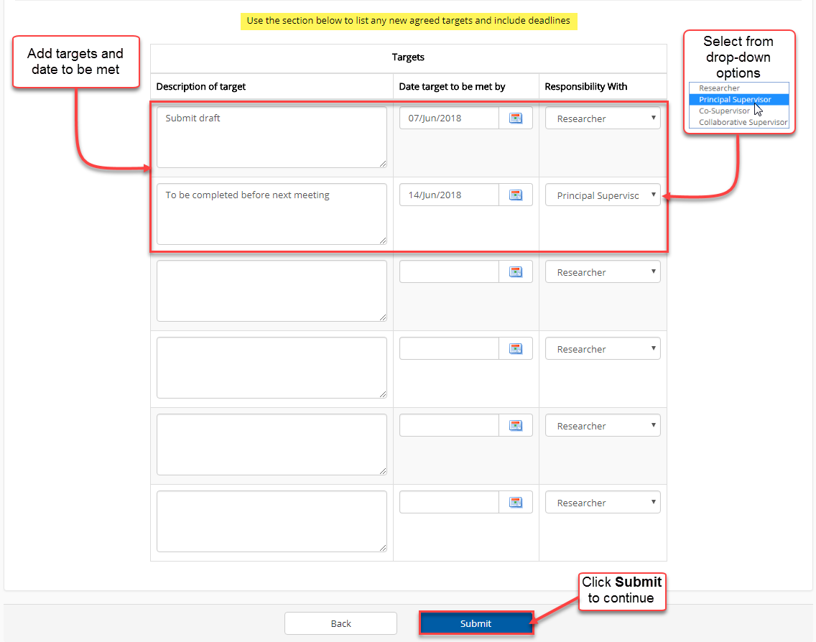

When ready, click **Submit.** This will send the submission to the person listed in the question “Meeting with” section (this can only be your Principal Supervisor or Co-Supervisor). You will no longer have the ability to submit notes after the deadline has passed. The deadline is usually around the 15th of the following month, so for example a September meeting record will be available to you to add notes from the 5th September until 15th October. After this date you will need to add your notes to the next month’s record.

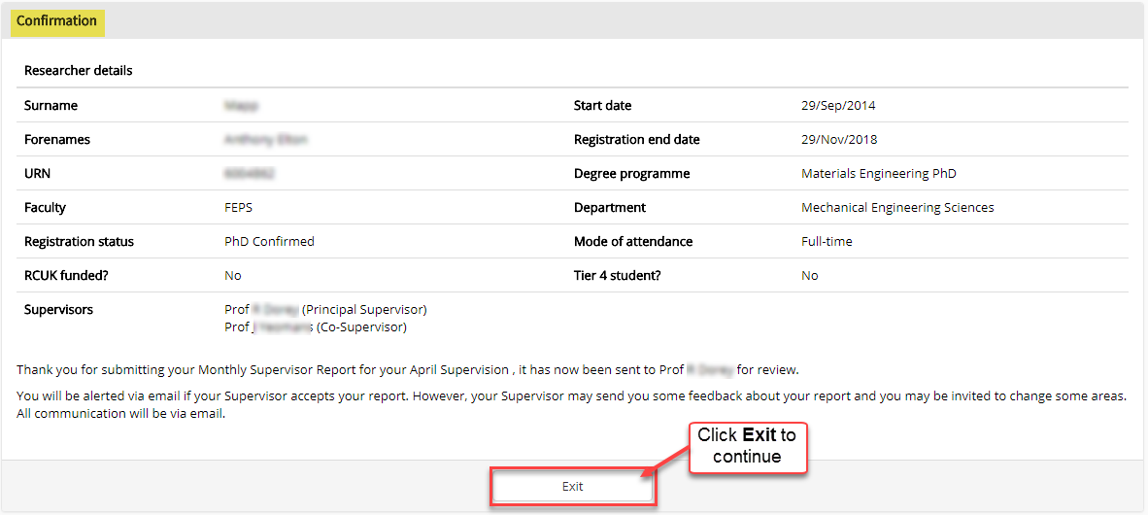

On returning to the **Monthly supervisions** tab, you will see the **Record of Outstanding Monthly Supervision Meetings** section includes an active link to **View Latest Submission Answers**.Click to view and track the submission.

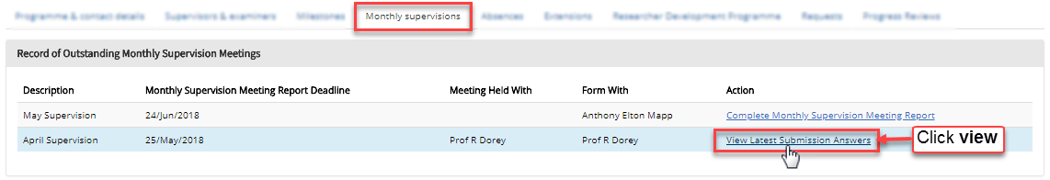

Viewing latest submission

Selecting the option to **View Latest Submission Answers** will open a detailed report providing an option to print or create a PDF version of the report

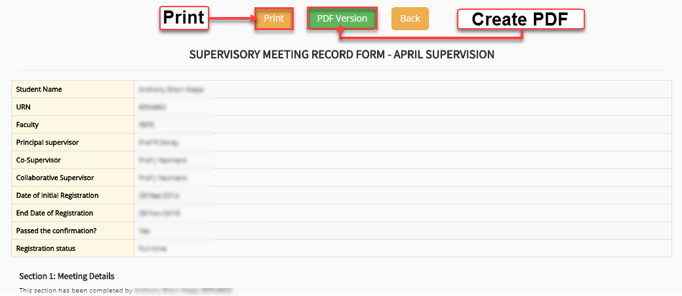

Supervisory Meeting Record Form

