Introduction

Access to the Post Graduate Research pages for submission of a new APESC request is through Surrey Self-Service. Log-in to Surrey Self-Service as usual.

Accessing the student PGR page

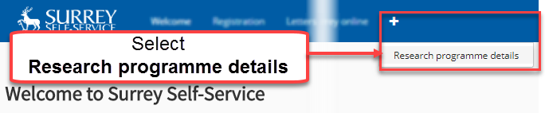

**From the menu** options select the plus  symbol to expand hidden menu options

**The Research Programme Details screen will be displayed showing Summary personal detail; Programme details; Thesis submission details. Check that the information given is correct.**

**Beneath the Summary details are a series of tabs (Programme & contacts; Supervisors & examiners; Monthly supervisions; Absences; Extensions; Researcher Development Programme; and Requests)**

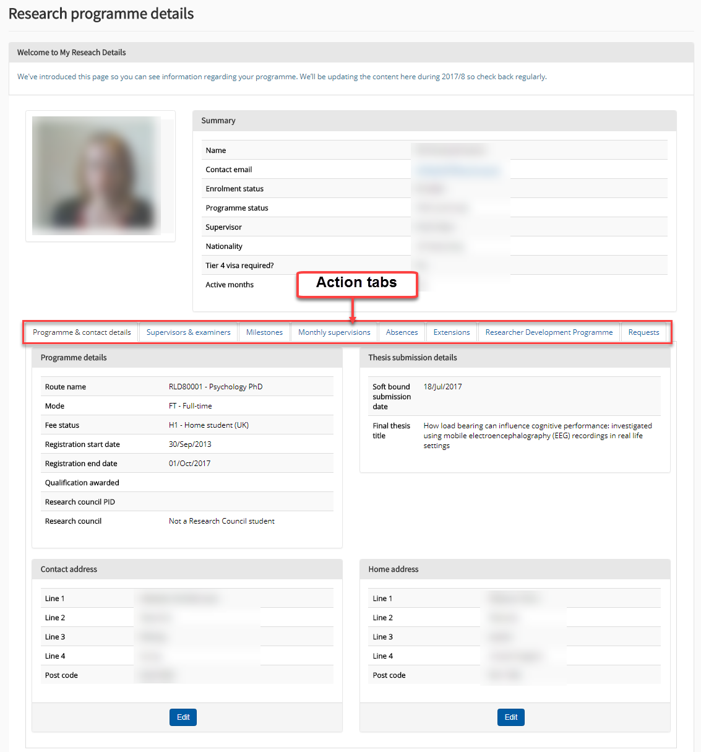

Starting and Completing a request

Various requests can be made including:

* Request a temporary withdrawal
* Request a change to mode of attendance (part-time/full-time)
* Request a change of programme
* Request a change of supervisor
* Request a transfer to completing status
* Submit your exam entry form
* Request an extension
* Request a permanent withdrawal

To launch the process, select the **Requests** tab.

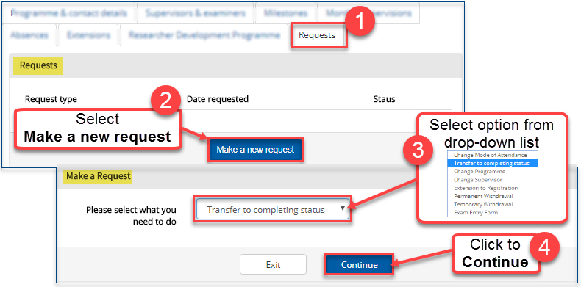

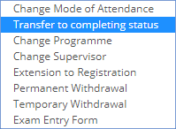

A form will be displayed the must be completed. In the example below the **Request for transfer to completing status** has been selected.

Carefully read the guidance provided in the upper part of the submission screen

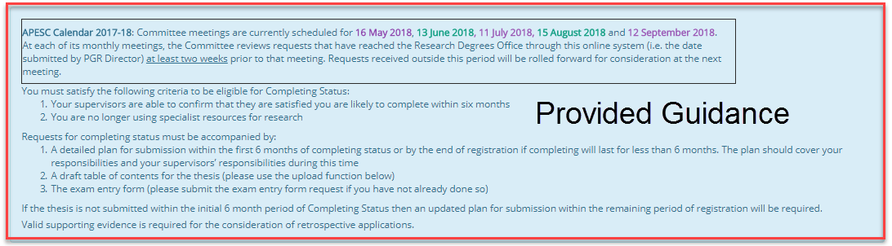

Sample of completed request submission

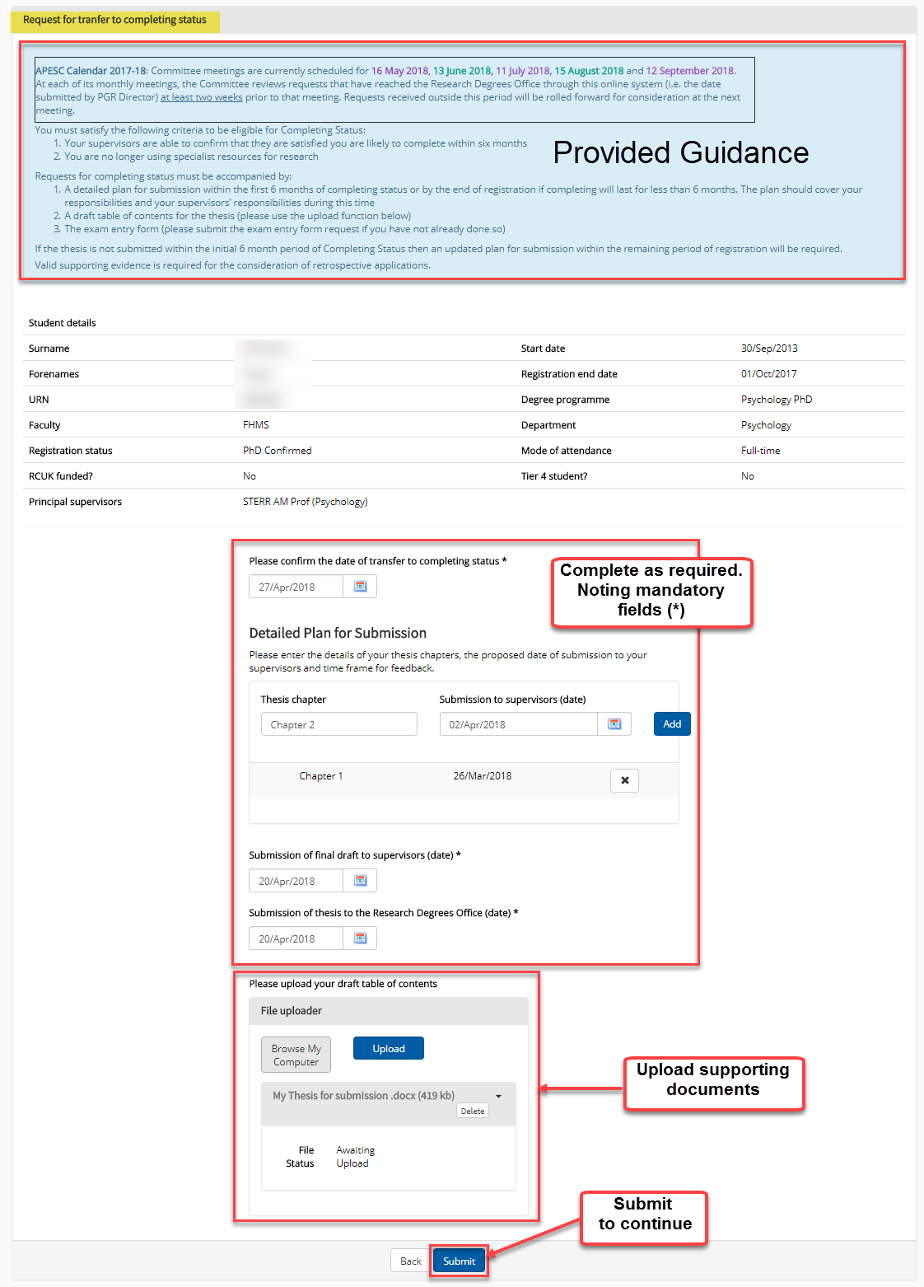

Confimation on submission of request

On completion and submission of your request your supervisior will receive an email notification and the following confirmation will be displayed

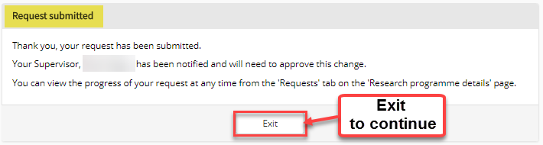

Viewing Request

